Pomodoring With Toodledo

The *Pomodoro Technique* is a time management method created by Francesco Cirillo in the 1980’s. It’s named after a tomato shaped kitchen timer that Cirillo used in college. This method focuses on using time productively to complete tasks, planning in advance and recording the process. A to-do list with special features is needed to successfully use the *Pomodoro Technique*, which is why Toodledo is the best option.

The technique suggests that you begin your day with a to-do list in order of priority. The list should include the date, name of task and estimated amount of pomodoro’s needed to finish the task. A traditional pomodoro is a 25-minute period used to intensely focus on a task, and a three to five minute break afterward. A 25-30 minute break follows four completed pomodoro’s.

Additionally, Toodledo can be used as your daily to-do list and is an easy way to incorporate the technique. It offers a simple way to quickly add tasks to your list using the quick add button. This can be done at the beginning of your day, like the technique suggests, then you can edit your tasks priority from high to low. Toodledo’s “tag” feature can be used to estimate the number of pomodoro’s needed, and then you can add the amount used. Each task has a notes field that can store any additional information about that task, such as 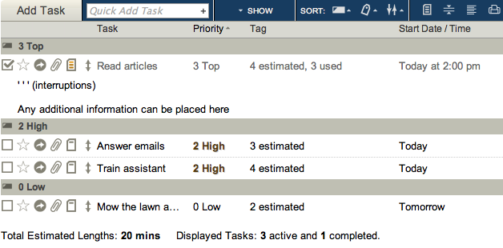marking each interruption.

After each task is done, you can go back and add the number of pomodoro’s used in the tag field, then check the task off as completed.

Next, recording and archiving reports is an important step in the technique. Cirillo explains that a report showing the start date and time, type of activity, description, number of pomodoro’s used and a short note should be archived to review and find room for improvements. All this information can be stored in Toodledo and backed-up and saved to your computer. Also, you can print your to-do list, along with all the information needed, and keep hardcopies filed away.

Finally, there are many other instructions that the *Pomodoro Technique* proposes, and Toodledo can be used in a customizable way to compliment them. Once you read and get the hang of the *Pomodoro Technique*, you can begin using Toodledo, watch the tutorial videos, and find the best way to use them concurrently.